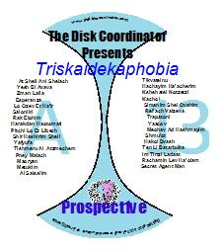
Welcome to the Prospect1ve aka A13 documentation. This is the first of four CDs released in the 13 series. It, and the Prospect2ve; aka B13, CD make up the Triskaidekaphobia, Volume 1 double Jewell case package.
Many people have helped in this release, some willingly, others knowingly and a few neither willingly nor knowingly. A hearty thank you to those below:

Music for the entire series: Don, Cherie, Grant, Sharon K and Tanya
Logo and Art: Deborah Kaplan
Additional Material for A13: Cherie, Naomi, Sharon K
Heavy use was made of the Aussie database which you can find and enjoy at www.israelidances.com
This documentation is being released in stages to the web site associated with these CDs, www.thediskcoordinator.com, where you will also find video listings to most of these dances. Additionally, the web site is being modified to allow users to locate teaching videos and music videos.
 | Music | Translation | T | Choreographer | year | Music | Time
1 | At Sheli Ani Shelach | You're mine, I'm Yours | P | Dudu Barzilay | 2008 | Composed by Yossi Ben David, sung by Eyal Golan | 1:58:03
2 | Yesh Bi Ahava | I have loved | P | Avi Peretz | 2006 | Composer and singer:Regev Hod | 2:30:51
3 | Zman Laila | Night Time | P | Avi Perez | 1996 | Composer:Avshalom Tsovra;; Singer:Haim Moshe | 2:51:03
4 | Esperanza | Hope (Spanish) | P | Rafi Ziv | 2007 | Composer:Eli Moshe; Singer;Mishpachat Aleyev | 2”10:73
5 | Lo Ozev Et Ha'ir | In the city | P | Yoram Sasson | 2003 | Shlomo Artzi | 1:56:45
6 | Saloniki (Al Hachof Be Saloniki) aka Thessaloniki | Saloniki | P | Naftaly Kadosh | 2005 | Vocal by Shar El | 3:07:51
7 | Rak Elokim |  | C | Erez Tabul | 2009 | Haim Israel | 2:36:58
 |  | Below, at the end of this documentation is a discussion of the sounds of this song. Two titles, Rak Elohim and Rak Ata are the same when listened to except for a few notes. Can technology help you determine this. Possibly not, but look for the discussion below.
8 | Harakdan Ha'automati | Automatic Dancer | C | Rachel Waitzman | 2003 |  | 3:16:58
We hope you don’t mind a little fair play entering these pages, but if you scan though the list of choreographers for the A13 CD, this and the next selection, are the only female names. It wasn’t always that way, we have been told, but males certainly dominate Israeli dance choreography, today. So, to even out the score, on a dance that is a staple at Cherry Hill and played somewhat at Don’s sessions, let’s tell you what we have found out about Rachel Weitzman through that portal of all discovery: Google.
In two words, Not much! The Aussie database has her listed for 5 additional dances. The only one this area might recognize is Belibi which may have been briefly taught at one time. If we ever get any more info, we’ll let you know.
9 | Pitchi Lo Et Libech | Open your heart to him | P | Yoni Carr | 2003 | composer:Ze'ev Nehama & Tamir Kalinsyc of Ethnix;;Ethnix | 2:35:43
The other female choreographer on this CD is Yoni Carr who is the choreographer of this partner dance. As opposed to the discussion above, there is plenty of information about Yoni on Google and you can contact her and trade Emails as the author of this documentation has proved. Per her Email we can report.
- Yes, she is a female. (previous versions of this documentation had this in error)
- She choreographed the above dance and it was among the top ten partner dances in 2005 at Gadi Bitton’s dance contest in Israel.
- She is the sister of the choreographer, Israel Yakovee.
- She runs classes in Southern California on Thursdays and Sundays.
- She has her own web site at www.israelidancing.com
We’d like to thank Yoni for her good humor in answering our Email to confirm some of this information.
As far as the Trisk I package is concerned (A13 and B13), Mali Lipson, Nourit Grinfeld, Rachel Waitzman and Yoni make up the female contingent of choreographers. Thanks to our fact checkers for bringing this (that Yoni is a female choreographer) and other errors to our attention.
10 | Shir Hashirim Sheli | My song of songs | C | Gadi Bitton | 2009 | Comp/Sing:Omri Glikman | 2:29:74
11 | Yafyufa[h] | Pretty Girl | C | Dudu Barzilay and Edo Israeli | 2009 | Composer;Adi L'eon;;  Singer:Eyal Golan | 2:09:28
We asked Cherie Maharam, the leader of the Pittsburgh session a few questions about this dance which Pittsburgh has added to its repertoire.
Q. How did you become familiar with Yafyufa? Was it through a camp?
Same way I hear about most dances: noticed the name on a list of dances taught (can't remember which camp). Looked it up in the Aussie DB and noticed that it was sung by Eyal Golan. We already do several dances to songs he sings (Chalomot, Metziu't Acheret, Shomreini El). His songs are always catchy. I saw that the choreographers Dudu and Edo: we already did many of Dudu's dances, and several of Edo's. Also, I liked that it was not really slow (we have so many slow dances!) or too fast (our dancers would whine and drop out).
Q. Would you consider this a difficult dance to teach? With your class, what was the hard parts for the class to master?
Medium level. Only two parts, not a lot of stuff facing outside -- so it was relatively unintimidating. The people in the group love the 2 stamps in the 2nd part. Everyone always stamps at just the right time, even people who don't know the dance well.
Q. To be fair, with about 6 to 7 thousand dances in the Israeli dance library, one has to wonder about the longevity of any new dance introduced. Do you think 5 years from now the Pittsburgh session will have this as a staple?
Good question. we only learn between about 20 dances each year, so we retain more than the average group (because we have fewer dances to forget!) I think it's possible we'll still be doing it in a few years.
12 | Tishmeru Al Atzmechem | Take care of yourself | C | Dudu Barzilay | 2008 | Composer:adi le'on;lyrics:Arlet Sfadia;singer:Haim Moshe | 2:26:09
13 | Pney Malach | Angel Face | C | Moshe Eskayo | 1995 | Composer:Stalios Potiadis;lyrics:Ilan Goldhirsh;  singer:Yoav itzchak | 2:50:18
We asked Sharon Kleban, the leader of the Wilmington session, several questions pertaining and related to this dance. Below are the questions and below that are her answers.
Q. When Don plays Pnay Malach at his Thursday session, you seem to be in the lead. What do you like about this song and dance?
Q. On the web site I have tried to indicate the appeal of Israeli dance music. To me, the genre has a very strong Arab or middle eastern beat. Do you get the same feeling when listening to this specific music? I know the Wilmington group likes Salamati, Al Salsalim and Tzel Midbar, all of which sound Middle Eastern. To your way of thinking, are we correct in assuming this is one of the appeals of Israeli dance?
Q. You’ve taught this dance at Wilmington, I believe. How did the students pick up the steps? What do you consider as the hard parts of this dance to teach?
Q.The dance is choreographed by Moshe Eskayo. Do you like most of his dances? It is said that he brings a Yemenite influence to his choreography. Where do we see that in this dance’s choreography?

Pnei Malach (Ed Note: The Aussie database indicates the spelling as Pnay Malach) is one of my favorite dances created by one of my favorite choreographers Moshe Eskayo. As I understand it, the song was originally Greek and was translated and re-recorded in Hebrew. To me, it is the perfect blend of Middle Eastern and western sounds. The steps and dance rhythm I would describe as very Middle Eastern. There are slow-quick-quick combinations interspersed with slow-slow-quick-quick-quick-pauses. I love the "break" section where the music changes to the chorus and the dance steps burst into running and turning jumps. The hardest part for me to learn was the slow-moving transition where the beat is almost completely even, like a walking pace. It feels so different from the rest of the dance that although the steps are much simpler they were harder for me to remember. I think that was the hardest part to teach to the Arden dancers too. We haven't done the dance that much, and I really need to teach it again.

I like the dance songs with a more Middle Eastern or Mizrachi sound. The western style music sounds like pop music I could hear on any radio station here, but if the dances are really fun then I end up liking the music no matter what it sounds like. Shmuot by Dudu Barzilai for example; love the dance but cringe at the music, especially the opening bars. I think the tension that comes from a minor key played joyously, Eastern drumming and string-picking and (mostly) Hebrew lyrics create a slightly exotic sound and when you add a dance I am hooked. I think the Arden group prefers the Mizrachi sound too, maybe because I play so many of these or maybe because it sounds ethnic and that's what Jewish and international folk dancers look for
14 | Maoryan |  | C | Dudu Barzilay | 2008 | Composer:Adi Le'on | 1:59:49
15 | Metukim | Sweets | C | Svi Levy & Dudu Barzilay | 1998 | Comp/Sing:Shlomi Shabat | 2:44:30
While this dance dates back a while, it was introduced last year at Naomi’s session in Cherry Hill. Like all the music on this CD (or at least that was the attempt), it has a fast and lively beat with very interesting steps – steps you would associate with a dance choreographed by Dudu.
One dancer has remarked about how people come and go in these sessions and for a while they are regulars and then you never see them again. They are in essence forgotten, especially in this type of dancing where the need to memorize new steps overrides the memory of older dance steps and the individuals who did them well.
The author would like to rectify this, even on a small, insignificant and fleeting scale, right here. Don’t know his last name. Don’t know where he went except back to Israel with his wife. But, whenever watching or doing this dance, he remembers Donny who used to be a regular at the Sunday Night Klein session and did this dance especially well.
16 | Al Salsalim |  | C | Yaron Malihi | 1998 | Comp/Singer:Shlomi Shabat | 3:21:67
17 | Tikvateinu | Our Hope | C | Kobi Michaeli | 2002 | This is a greek dance Singer:Esta | 3:06:65
18 | Hachayim Ha'acherim | The other life | C | Avi Perez | 1995 | Composer:Yoni Ro'eh;;  Singer:Leah Lupitin | 2:30:02
19 | Kshe'hatal Notzetz | When the dew is glistening (Shining) | C | Israel Shiker | 1993 | Composer:Meir Goldberg;;  Singer:Uri Fineman | 2:47:31
20 | Kachol | Blue | C | Shmulik Gov Ari | 2004 | composer:Uri Miyls | 2:31:31
21 | Simanim Shel Ohavim | Signs of Lovers | P | Ohad Atia | 2010 |  | 1:50:23
22 | Rei'ach Valzeva | Scent and color | C | Avi Perez | 1993 | Composer:Doron Mazar;;  Singer:Doran Mazor | 2:13:06
23 | Trapatoni (aka Bachof Shel Trapatoni) | (on the beach of) Trapatoni | C | Meir Shem Tov | 2003 | Lyricist:Shlomi Shabat;  Singer:Shlomi Shabat | 2:23:57
24 | Yaacov | Jacob | C | Gadi Bitton | 2009 | Composer:Geri Valodovski;;  singer:Laladin Ben | 2:35:06
25 | Meohav Ad Hashamayim | In Love up to the clouds | C | DuDu Barzilay | 2010 | Singer:Yoav Itzchak | 2:46:57
Pertaining to this dance, we asked Naomi, the leader of the Cherry Hill session, the following questions:
Q. We believe your class was the first in this area to study Meohav Ad Hashamayim. How did you become aware of this dance?
First I had just heard of it--I'm not sure how--then a regular Cherry Hill dancer saw it at a session in California and said that she liked it, so I took a closer look at it and decided it would be a good dance to introduce to the group.
Q. We have Dudu Barzilay as the choreographer. It would seem that Dudu is one of your favorites as far as dances taught. Is this correct? What do you consider in his choreography as most attractive?
I do like many of Dudu Barzilay's dances, though I also like many dances of other choreographers. I make decisions about dances to teach based on the particular dance, not the choreographer.
Q. One would assume that any dance taught would have its easy and hard parts per your class. What are the hard parts in teaching this dance? Does the ease or difficulty in what you perceive as to instruction influence what you decide to teach?
I don't think that most people found any parts of this dance difficult per se, though I guess one of the harder parts is the end of part 1 with the stamp in the middle and then somewhat unusual rhythm of steps coming back out of the circle. I do not choose dances based on how difficult they will be to teach, though I try to introduce dances with a range of difficulty levels to the group (so that everyone can "get" some dances, while the more advanced people will be challenged by other dances).
26 | Shmu'ot | Rumors | C | Dudu Barzilay | 2007 | Composer:Adi Le'on;Lyricist:Yosi Gispan;  Singer:Eyal Golan | 2:19:44
27 | Hakol Dvash | All is honey | P | Avi Perez | 2005 | Composer:Doron Mazar;;  Singer:Doron Mazar | 2:10:05
28 | Ten Li Batarbuka | Give me a Tarbuka | C | Gadi Bitton | 2001 | Singer:Hamsa | 2:20:61
29 | Im Tirtzi Lada[']at | If You Want to Know (said to a woman) | C | Gadi Bitton | 2004 |  | 2:25:69
30 | Rachamin Lev Ha'olam | Mercy is at the heart of the world | C | Avi Levy | 2002 | composer:lea shabat;singer:Lea and Shlomi Shabat | 2:34:55
31 | Secret Agent man | Secret Agent Man |  |  | 1966 | Composed:Steve Barri and PF Sloan;;Singer:Johnny Rivers | 2:57:50

Note to the kicker to the prospect1ve, A13, CD
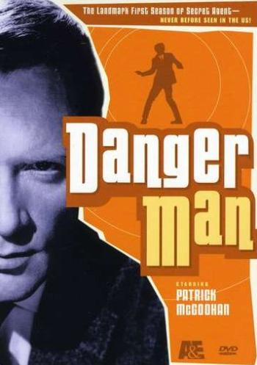
In 1960, a half hour British television program was to be created cashing in on the James Bond craze. Although the Bond movies were yet to be produced, the Bond books and Bond portrayed in a set of comic strips were very popular in England and this popularity would be exported to the US within a year or two partly through a Life magazine story about the favorite books of President John F Kennedy, one of which was From Russia With Love, the subject of the G11 kicker documentation.
It has been reported that a television producer for this proposed series had met with Ian Fleming, creator of the Bond books, to ask his opinion (and possibly his association) about this proposed television series, but Fleming had already signed a contract with other parties in terms of the rights to the Bond character. This would not be the last time a TV producer met and discussed ideas with Fleming. For trivia fans, this is an answer to the question of how the 60's American TV program, The Man From Uncle, was created and conceived. We'll give you a hint by indicating the lead character's name of that show, Napoleon Solo, is the name of a character in the novel, Goldfinger.
But we digress and will indicate to the reader that this is how the television series, Danger Man, started from scratch. In the process of getting onto the air, it cast a very dramatic, but opinionated actor as its lead. Possibly a great move, possibly a bad move as this actor would gain some control over the character he portrayed both to the benefit and detriment of the series.
The actor, born in the US (but at 6 months repatriated with his parents back to England) was Patrick McGoohan. The protagonist of this TV show, Danger Man, was John Drake. McGoohan was a highly intense perfectionist who showed this time and time again in the theater. To him, nothing was gray as far as acting was concerned. Everyone who has dealt with him claims his acting was a form of perfectionism, something he also insisted on others when in command. This author has read several reviews of McGoohan’s plays and critics generally said that he would envelope a part with great passion and projection.
McGoohan, contrary to most actors those and these days, was happily married since 1951, a marriage that would last until his death in 2009, and had a very high expectation of social and, should we say, sexual morals and situations. This was not an actor to be portrayed going from bed to bed. Although the John Drake character was not so written at the beginning of the TV series, McGoohan immediately put that stamp on the role he played. While, no doubt, he was as adamant as far as other ethical and moral conditions were concerned, there was a more gradual inclusion of this ethos into the program, but included it was.
Danger Man was originally designed to also play in the US market but its half an hour format, appropriate in the UK, was not such in the US. Its duration on British TV was two seasons. In the first season, a very limited music theme was installed - just a few chords - but by the second season, apparently what’s known as the highwire theme became the standard. A version of this Highwire theme will be the kicker to the Retrospective CD when it is released in October. In listening to it, any James Bond influence as far as music is concerned is missing given that it was created before the Bond movie successes. It seems to have as its influence the Harry Lime theme (now generally known as the Third Man theme) from the movie, The Third Man. You'll be able to determine if this author is correct in his assumption as the Third Man theme is the kicker for the Introspective CD also to be released in October.
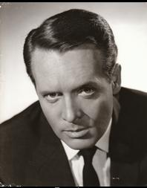
Obviously, with McGoohan vetoing most plot lines, the writing and direction would have to take a different, higher level direction. Production was stopped for several seasons. It gave Mcgoohan time to pursue other roles. While off, McGoohan starred in a Disney production, The Scarecrow of Rodney Marsh, and other movies and plays. He also had the opportunity to say no to the role that would make Sean Connery famous, the aforementioned James Bond. In McGoohan’s case, being turned off by the character, it was a flat no to even auditioning for the role and who knows whether he would have been offered the part or not. His wife in later years reported that he never even considered becoming the actor to lead James Bond onto the screen although the producers of the first movie, Dr No, were very eager to see if he could be so cast.
When Danger man returned to the air it was now as an hour long drama. In the UK it was still titled Danger Man but in the US, where it started to be picked up as a syndicated show, it had two titles, the title with the most staying power was Secret Agent or Secret Agent Man.
The kicker to this CD, the last music selection, is why this name stuck. A new theme had been created using American artists. The theme was created by the song writing team of Steve Barri (supposedly born Steve Barry Lipkin) and PF Sloan who probably, if you listen to the lyrics, like most Americans projected James Bond onto John Drake. It was further modified – to, could we say, an Elvis type of sound by the singer, Johnny Rivers. For whatever reason, the theme invoked the words “Secret Agent Man” and this is what American viewers remember having had no history of the half an hour Danger man production.
From a music standpoint (and from a standpoint of these CDs) the intro guitar riff is a parody on the beginnings of the James Bond theme. Given the popularity of these movies (Secret Agent Man was in production from 1964 through 66 at the height of Bondmania) almost every guitar riff had elements of the most famous guitar driven song in the world at the time. This was no exception. But once into the theme, Johnny Rivers, the artist and singer to whom you are listening, made this song into a hit of its own and supposedly in 1966 this song topped out at #3 on the billboard chart of most favorite songs in this country. We might add that Johnny Rivers was a very accomplished musician in his own right and was very well known during the 60's for such hits as Memphis and Maybeline.
One more note: On the internet there are multiple renditions of Johnny Rivers singing this song with just three verses. We have made sure to include with this CD the version that has the instrumental third verse. Listen to the guitar: it very highly styled. All of this would have been academic as far as the TV program was concerned as only the first verse was heard.

Notes on Rak Elokim.
A very popular singer in Israel is Chaim Israel also spelled as Haim Israel and pictured on the next page. Besides this song, the disk coordinator data base indicates the partner dance, Lecha Eli, as also sung by him which we dance to in this area. The Aussie database lists quite a few dances attributed to his songs but many are not danced locally. You can see references to his albums on YouTube (and the internet in general) by typing in his name.
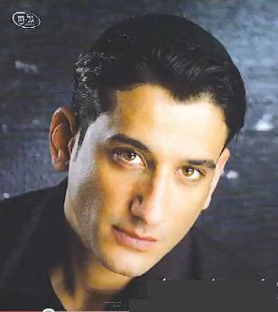
During the first half of this year, Don introduced a dance to one of Haim Israel’s musical pieces set to the song name referenced here and on the label of this CD, Rak Elokim. The choreography is attributed to Erez Tabul and the date of this is 2009
However, when dancers returned from Sababa over the Memorial Day weekend, it seemed like a different choreography had been set to the same piece of music. The choreography in this case was by Moshe Eskayo and the date attributed is 2010. The music was now designated as Rak Ata but the singer remained Haim Israel.
Supposedly, modern Israeli dances are to have one set of steps to one piece of music to avoid confusion as may have happened in the past. Someone once mention to this author the process by which this is done and the explanation was confusing to him then so there will be no repetition here. You’ll have to find your own person to confuse you as far as these rules and regulations.
However, we may be able through technology to answer where the difference, rather small, occurs in the pieces of music referenced above. Luckily, the disk coordinator was able to take off enough time from his day job of radar technician/sonar operator to prepare the following diagram for you that you can see on the next page (for those into technology, this is a jpg file and cannot be split in word processing programs between 2 pages). These spectrum waves are from the author’s version of Nero that he uses to burn the diskcoordinator CDs and to analyze music.
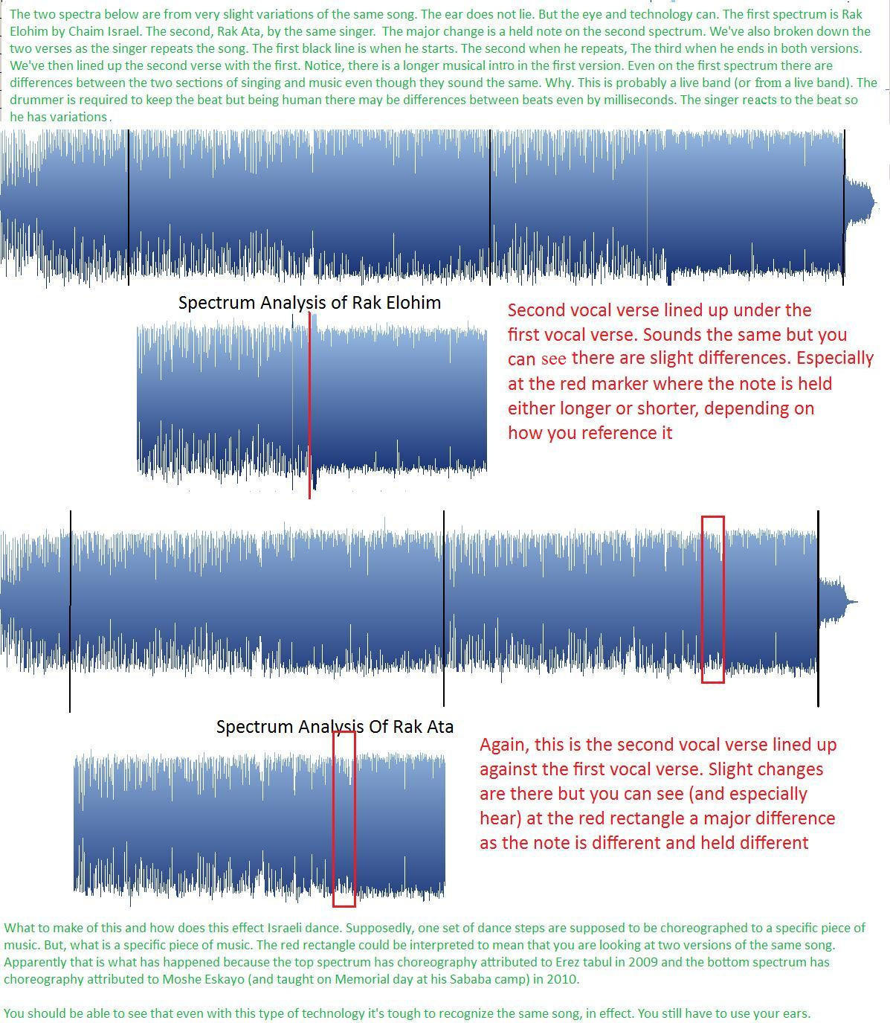

This CD, part of the 13 series, is distributed free of charge to the Israeli and International folk dance sessions covered by www.thediskcoordinator.com. There are absolutely no rights reserved.
Welcome to the Prospect2ve aka B13 documentation. This is the second of four CDs released in the 13 series. It, and the Prospect1ve, aka A13, CD make up the Triskaidekaphobia, Volume 1 double Jewell case package.
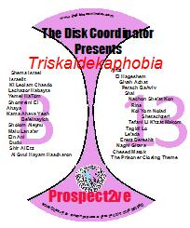
Many people have helped in this release, some willingly, others knowingly and a few neither willingly nor knowingly. A hearty thank you to those below:

Music for the entire series: Don, Cherie, Grant, Sharon K and Tanya
Logo and Art: Deborah Kaplan
Additional Material for B13: Grant, Jane
Heavy use was made of the Aussie database which you can find and enjoy at www.israelidances.com
This documentation is being released in stages to the web site associated with these CDs, www.thediskcoordinator.com, where you will also find video listings to most of these dances. Additionally, the web site is being modified to allow users to locate teaching videos and music videos.
 | Music | Translation | T | Choreographer | year | Music | Time
1 | Shema Israel | Hear O'Israel | C | Shmulik Gov Ari | 2005 |  | 2:28:06
In looking at both the A13 and B13 documentation, while not the most prolific, the choreographer of Shema Israel, Shmulik Gov Ari, is well represented. He is the choreographer of many repertoire dances of the various groups covered including Kol Niderai and Boker.
It is not unusual to talk with dancers in this area who relate attending sessions run by well known choreographers in other parts of the world, especially in trips to Israel. It is rare to hear such a discussion in terms of local venues. However, with Gov Ari, we have an exception. Although it is impossible to document this to an absolute certainty, apparently Shmulik was a resident of the greater Philadelphia area during the early to mid 90’s and ran dance sessions in Cherry Hill, center city and Bala Cynwyd. Apparently many of his dances that we now take for granted had initial choreography that he first tried out on our local dancers during that time period in the locations mentioned above. However, this one which was choreographed in 2006, has no local ties.
2 | Israelit | Female Israeli | C | Gadi Bitton | 2008 | composer:Tomer Hadadi;;singer:Ilanit | 2:40:31
3 | Ki Leolam Chasdo | For his charity never ends | C | Avner Naim | 2008 | Singer:Tzion Golan | 3:04:42
4 | Lachazor Habaita | Returning Home | C | Gadi Bitton | 2009 | Composer and lyrist:Keren Peles; Singer:Boaz Ma'uda | 2:30:58
Lachazor Habaita was introduced by Gadi Bitton at either Montreal or Toronto in 2009. Most of the groups in the Phila area have made this part of their repertoire including Germantown. We asked Grant, the Germantown session leader, for his thoughts on this dance
Q. I believe you introduced this at Germantown (correct me if wrong)– Jani[Rosen] was scheduled and couldn’t make it. It had been introduced in Toronto previously. What had you heard about it that made you want to teach it.
Q. Now, the choreography is by Gadi Bitton. How would you describe the steps per the dance and how does this compare to Gadi’s other dances taught at Germantown?
Q. The Germantown session is beginner to intermediate. What are the pitfalls in teaching this dance to beginners and intermediates given that it seems hard?
Q. What is the feedback you have gotten from the dancers as to this dance.
Q. You introduce many dances – some from you, some from Jani and some from Don’s yearly seminars. Some of these dancers disappear from your repertoire. Do you think this dance is a keeper? Five years from now will we be dancing it?
Honestly, I can't recall exactly the back story for teaching Lachazor Habayta. I think it was Jani that brought it to my attention, and what grabbed me most, I think was the music, the beautiful sweeping melody.This dance, in my opinion, is unlike many other dances in that it doesn't really have distinct repetitive parts. Most of the steps create one long continuous arc, that itself repeats. I think that our dancers enjoy this dance mainly because of its beautiful melody.
As for its longevity, I think it may not survive long term. The dances with staying power tend to have steps and sequences that are more intuitive than this one. But....time will tell!
5 | Yemei HaTom | Day Of Innocense | C | Mali Lipson and Moshe | 2006 | Composer:Tzuria Lahav;;Singer:Rita | 2:04:08
6 | Shomreni El | Preserve me, God | C | Dudu Barzilay | 2009 | Composer:Adi Le'on;;Singer:Eyal Golan | 2:37:49
Jane Tardell recently became the session leader for the class in Staten Island. Jane has been dancing for many years, but being a leader of a session is new for her. She was nice enough to answer the following questions about teaching Shomreni El and her experience as a new session leader during an Email exchange.
Q. Being in Staten Island, we’re sure you have a different perspective on certain dances than 90 miles down south. The Philly dancers first saw Shomreni El in 2009 at Hora Aviv and it was taught by Mimi Cogan. No doubt you saw it at another camp, possibly taught by the choreographer, Dudu Barzilay
I learned the dance from the choreographer Dudu at Rikud Boston 2009. It was the "hit" of the camp and the one everyone kept requesting to be played over and over.
Q .Do you think from a instructor standpoint, as you prepare to show this to others, that it matters who originally shows you a dance?
I am answering this both as an instructor and as a dancer. It doesn't matter who originally shows me a dance, and although I have an excellent teacher that I dance with 3-4 times a week, I always try to watch a video of the choreographer doing his/her own dance. I like to see their style, their body and arm movements, the little nuances that make the dance uniquely theirs.
Q. You have indicated that your class is beginner/intermediate. This is not that easy of a dance although by no means is it advanced. Why did you choose this dance to teach?
I taught this dance later in the evening and only to the more advanced dancers. I chose this dance based on the following criteria that I use whenever I pick a dance to teach:
1) I personally like the dance and the music and know that I will not get tired of dancing it week after week.
2) I think that the dance has staying power and will be around for many years to come.
3) I know the dance well enough to be able to speak the steps during the teach and to call the steps in advance during the dance. This is a new skill that I am still learning.
Q. For any type of class, beginner to intermediate – timing is always an issue as far as Israeli dance is concerned. There are several timing situations with Shomreni El – in the second part as you reverse spin into the center and the entire tag (or third part) of 8 steps. How do handle the discussion of timing of steps with your class?
This is a tough one for me since I am not a trained dance teacher. I honestly don't know how to handle or teach timing. I often tell my fellow dancers to just "listen to the music and it will tell you what to do." With me timing is an instinct, either you hear it and feel it or you don't. Can it really be taught? I know people who have been dancing 20-30-40 years and are still off the beat.
Q. The disk coordinator follows his alter ego in trying to type (or set metrics to) dances. We are of the opinion that this is not a typical Dudu Barzilay dance, if such a thing can exist, as there is no sweeping motions in any of the parts such as you would find in Meohav Ad Hashamayim, for instance. Are you of the same opinion? Would a typical Dudu dance such as Meohav be appropriate for your class?
Funny that you should mention Meohav Ad Hashamayim since I just taught it to my class and they loved it. Guess that I did teach some timing with this dance since I found myself calling out "one--one,two" over and over to get them to feel the rhythm.
Q. Speaking of your class and teaching. You took this over recently. It seems as if a lot of Israeli dancers think that they could easily lead a group. Even more so, probably at little or no expense. With your new experience, we doubt if you feel that way although we could be wrong. For the one or two dancers who will even read this and would like to create and run their own class, could you give them some inside pointers in doing this?
Although I have been dancing for many years I never thought that I could lead a group. In fact I often said that I would never teach because I didn't want to turn something that I love into a job. I very reluctantly took over "temporarily" just to help out until the group found a new permanent leader but it looks like I'm it. It helps that we already have a place to dance with no rental fee. It helps that I already have a collection of hundreds of CDs and DVDs. It helps that I attend 4-5 dance camps a year. It helps that I have a very good job and can afford to spend thousands of dollars a year on my hobby. And it helps that I am obsessive/compulsive and seriously addicted to Israeli dancing.
7 | Ahya aka Ahaya |  | C | Gadi Bitton | 2000 | Composer:Avihu Medina;;Singer:Ofri Salem | 2:30:38
8 | Kama Ahava Yesh Be'einayich | How much love is in your eyes | C | Israel Shiker | 2009 | Lyricist:Yosi Gispan;Singer:Uri Fineman | 3:45:71
9 | Od Yavo Shalom (salaam) | Peace be with us | C | Shmulik Gov Ari | 1998 | Composer:Moshe Ben Ari;Lyracist:Moshe Ben Ari; Singer:Lahakat Sheva | 2:37:07
10 | [16] Malu Lana'ar | The boy turned 16 | P | Michel Cohen | 2010 | Composer:Kobi Oshrat;Lyracist:Eli Mohar;Singer:Gabi Shoshan | 2:06:20
11 | Ein Ani | I'm Not | C | Meir Shem Tov | 2002 | Composer:Amit Carmeli;;Singer:Shotei Hanevu'a | 3:17:61
12 | Dudu | Dudu | C | Bonny Piha & Yoram Sasson | 2003 | Singer:Tarkan Tevetoglu | 2:40:42
13 | Shir Al Etz | Song of a tree | C |  |  |  | 3:18:36
14 | Al Gvul Hayam Haacharon | At the edge of the ocean | C | Victor Gabay | 1996 | Composer:Nachum Hayman;;Singer:David D'or | 2:39:09
15 | Artzi | My Land | C | Tuvia Tishler | 1996 | Composer and singer:Rami Kleinstein | 3:10:51
16 | Et Hageshem | The rain | C | Eli Ronen | 1983 | Composer:Shmuel Imberman;;Singer:Shlomo Artzi | 2:01:36
17 | Givah Achat | One Hill | C | Rafi Ziv | 2009 | Composer:Shlomo Artzi;;Singer:hagivatron | 3:44:35
18 | Shai | Gift | C | Tuvia Tishler | 1996 | composer:Levi Shaar | 2:03:15
19 | Perach Ba'Aviv | Flower in the Spring | P | Ohad Atia | 2005 | composition, lrics and singing by Sagiv Cohen | 2:36:74
20 | Nachon She'at Kan | It's true you are here | P | Nourit Grinfeld(Greenfeld) & Marco Ben Shimon | 2009 | all by Daniel Solomon | 3:05:73
21 | Rina | First name | P | Tuvia Tishler | 1993 | composed:Issak Doniveski | 2:42:10
22 | Kol Yom Nolad Shetachzeri | Each day is made for your return | P | Gadi Bitton | 2006 | Composer:Amir Dadon;Lyrics:Ophir Simchi;Singer:Yoav Itzchak | 3:14:22
23 | Tefani Li K[']tzat Makom | Make a little room for me | P | Victor Gabay | 2000 | Composer and singer:Yoav Itzchak | 2:48:45
24 | Tagidi Lo | Tell Him | P | Gadi Bitton | 2005 | Composed, lyrics and singing by Ohad Chitman | 2:16:55
25 | Le'ada | For Ada | P | Roni Simon Tov | 1986 | Composer:Moshe Wilenski | 3:08:21
26 | Eretz Bereshit | A biblical land | P | Avi Perez | 2009 | Composer:Shmuel Elbaz;Lyricist:Yosi Gispan;Singer:Ilan Nuri | 3:16:36
27 | Nagni Gitara | Playing the guitar | P | Israel Shiker | 2009 | composer&lyrics:Yoni Ro'eh;singer:Avi Sinuani | 2:34:08
28 | Chesed Matok | A sweet kindness | P | Ze'ev Benedict | 2009 | Composer:Shmuel Elbaz;;Singer:limor Tovim | 2:46:25
29 | The Prisoner Theme |  |  |  | 1967 | Composed: Ron Grainer | 1:06:60
Note to the kicker to the prospect2ve, B13, CD
We left the discussion of the A13 kicker at the point where the 1 hour Danger man/Secret Agent was about to be produced. It was a hit in both the US and especially in the UK. This success is at a time when the Bond movies are rolling along and there are many Bond movie imitations on the Big and Little screen. The aforementioned Man From Uncle ran on NBC in the United States from 1964 through 1968.
In the era of the spy and the supposed spy life style, Secret Agent was very different. Patrick McGoohan, at the helm of John Drake, in essence, elevated this character as has been observed by many sources including this writer who remembers being a fan of this show. To some degree, this representation of character more closely followed Ian Fleming’s interpretation of Bond with a notable exception which we’ll let you think about assuming you have read the A13 and G11 kicker documentations.
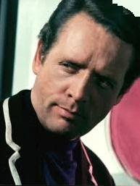
For McGoohan, as with Sean Connery, success opened up many opportunities in TV and movies as he became one of England’s most popular actors at a time when that country was still generally filming in black and white. However, by the mid 60’s, much of the country had color sets and many shows flipped over to color production as did Secret Agent/Danger Man in ’67. Two episodes for that season were supposedly filmed when McGoohan dropped his bomb shell.
What is it with actors in successful enterprises? They all like the fame, no doubt the fortune, but this comes with the need to act in something else. They are not content to a final interpretation of a character and, unfortunately, successful TV shows or movies create this type of situation. No, there is need for new characters to build on.
Israeli dancers to some degree understand this. A minority would be content to keep dancing the same dances forever but there is a majority who want newer, different, more innovative dances to be studied, memorized, danced to , enjoyed, reinterpreted before the eventual and inevitable fading of enthusiasm for the old as newer dances get so applied.
So, similar to Sean Connery as James Bond, not to mention various dancers over the years, McGoohan tells his producers, that’s it, He’s quitting. Apparently his contract is written so that at any time he can walk and walk he does after the first 2 episodes of the new season never to come back as John Drake.
What would you do if you were Lew Grade, the executive producer (the head honcho) of the network producing and airing this series. Your star has walked and It’s apparent that he will never return to this role that he has defined to the nth degree. No-one is irreplaceable, but the closest anyone has ever gotten is Patrick McGoohan’s status at that time.
Lew Grade responds in the following manner - perhaps you would also – by querying his most prominent actor with a sort of, ‘Well, what do you want to do? Whatever you want, let’s do it!’ The resolution of this answer creates what many consider the most unique and most frustrating TV Show ever presented. It is a show that defines, enhances and destroys this actor’s career given that the actor has taken complete control of the project. It is in a nutshell: James Bond meets Kafka!
In a long about way, this brings us to the kicker of this B13 disk. We are, of course, referencing the Prisoner TV series. If you’ve never watched the series, before reading further, listen to this music. What do you hear? What do you feel? Most listeners would say that the percussion denotes movement, marching, perhaps the need for escape. The strings denote anger and forcefulness as they are played. You now have the gist of the Prisoner TV series. The high moral standing John Drake, who is never officially named, has had enough. Someone in his secret organization has done something his morality cannot tolerate. He is resigning!
However, this is not the situation where you resign, take a few weeks off and find another job. No, this is an organization which follows you home, drugs you into a coma while in your apartment and from which you wake up in an exact duplica of your residence within “the village”, a place of no escape where the question, asked a million times a day and in as many ways, is “why did you resign?”
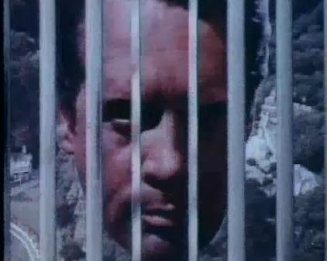
We will not discuss the underlying morality of this program. If you’ve never seen the show, it’s available on DVD. We will limit our statements to the fact that few shows, if any, have had such recognizable visual accoutrements. From the romance architecture of the outdoor scenes of the village (Portmerion in Wales, famous in its own regard), the caricatured dress/design, the pennyfarthings and similar vehicles, the décor of the interiors, names if numerics are your thing and, of course, rover – the final defense of the village - It all comes out of the mind and genius of one man, Patrick McGoohan, No. 6, who is the lead actor, lead writer, often director of the show. And, the frustrating ending, episodes 16 and 17, in essence destroys his acting career in England and he is somewhat forced to relocate to California – on his own accord and not drugged to be sure - always pursued by the question, also possibly asked a million times a day, what’s the ending of the last episode mean?
We can’t give an answer either. Luckily, we are interested in the music. There are two themes in play with the Prisoner, one at the beginning of the hour as the show would start and one at the end to which you are listening. The beginning theme is much too long for these CDs and is rendered in two parts: before the drugging and then after. On the Internet (and Youtube) you can find this if you like. The ending theme is the one played here and is much shorter and in one piece.
The composer is Ron Grainer and his first attempt at a theme, which you can also hear on the net, was very low level and subdued. Mc Goohan, who was in charge of everything including the selection of music, wanted something more dramatic, loud and explosive and Grainer just took his original interpretation, doubled the speed and increased the volume fourfold. This is what you are hearing.
We hope you enjoy the music. If a prisoner fan, we’re sure this brings back memories and if not, perhaps this is something you might want to research although probably not to this degree.

This CD, part of the 13 series, is distributed free of charge to the Israeli and International folk dance sessions covered by www.thediskcoordinator.com. There are absolutely no rights reserved.

Fact Checking on the Trisk I package.
Transliteration from a different type of language is always a problem. Hebrew and Arabic are part of the Semite family of languages while English is part of the Indo European family so there is no consistency in moving from one to the other. To that end, song titles have been checked against the aforementioned Aussie data base and the English transliteration on that site has been used. Nevertheless, we asked Barbara Jaffe, an avid Israeli dancer who lives in the Washington, DC area to proof read and review this documentation and here is her comments:
A13
Z'mon Layla – (I would spell it) Zman Layla (nighttime)- but of course transliterating Hebrew is subjective – but I pronounce it with a long ‘a’
Pnei Malach – (aka Yaldati) [Ed Note: We are using the Aussie database designation of Pnay Malach]
Rei'ach Valzeva – Rai’ach v'Tzeva (tzeva for color—e.g. smell and color) - Avi Perez (or Peretz) I believe
Yoni Carr is the sister of Israel Yakovee. (Ed Note, This has been corrected)
B13
Artzi - Tuvia Tusler (It’s Tuvia Tishler) [Ed note:This has been corrected]
El ha geshem – isn’t it et ha geshem [Ed Note:This has been corrected]
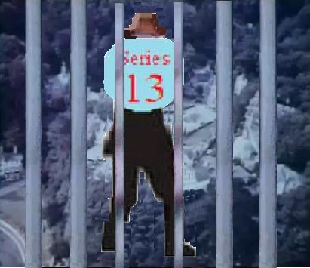
Nachon she at kon – I would say kan – long a – for “here” –(It’s true that you are here) – my CD from David Dassa’s 2009 pre-Thanksgiving marathon also says Kan
It is Mali Lipson and not mali Lipton (Ed Note: This has been corrected)
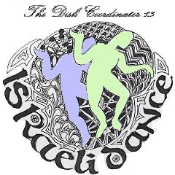
Additional Notes on the 13 series in General.
These two CDs, A13 and B13, make up Triskaidekaphobia Vol 1. Two other CDs, C13 and D13, scheduled to be released in Oct’10 as part of Triskaidekaphobia, Vol II will have their own documentation.
The author of this, who plans to soon commit himself to some institution for even contemplating this project, never expected this release to get to this level. It begins innocently enough as the result of attempts to back up music for the Germantown and Wilmington groups. In sorting through the music at that point made available to him, and with the realization that the Memorial Day camp, Hora Aviv, may have come to an end, it seemed that a 3 CD set of Israeli dance music was possible. Initial efforts proved a 4 CD set would be the most practical way to showcase the music we dance to and in the end this is the ultimate purpose of these CDs.
With the original 3 CD idea, the only thing this author could come up with concerning interrelated kickers of music was music themes of the Danger man, Secret Agent and Prisoner TV shows. He will readily admit to being a fan both of these shows and their music. Perhaps, also, publicity of Patrick McGoohan’s death last year was retained subliminally to abet this idea.
To start this project, we asked Deborah Kaplan, professional calligrapher and teacher, to create a 13 series logo, which is on the CDs and displayed above on the left. This logo has been color coded for all the components
This author did not expect and was extremely surprised to run into direct influences pertaining to his favorite author, Ian Fleming, the subject of the G11 kicker. Once that occurred, it was off to the races as far as research was concerned and the individual involved still can’t believe the time wasted researching what you have been reading as far as kicker documentation. He also apologizes to subjecting you, the reader, to all this. Of course, perhaps this was pre-ordained. If you do add the Prisoner, No 6 to everybody’s favorite secret agent, 007, you will wind up at 13 but it was certainly unexpected.
Normally at this point in the documentation, we tell you that this is the end of the 13 series (although Volume II will debut in October), and we’ll return with the 14 series sometime in the future. We think you will understand, though, that this will not be for a while. But, this project does allow us to fulfill a fantasy all Prisoner TV show fans will appreciate and understand. It allows us to say:
Be seeing You

